CURRICULAM VITAE

General Information:
Name: Prince Kumar 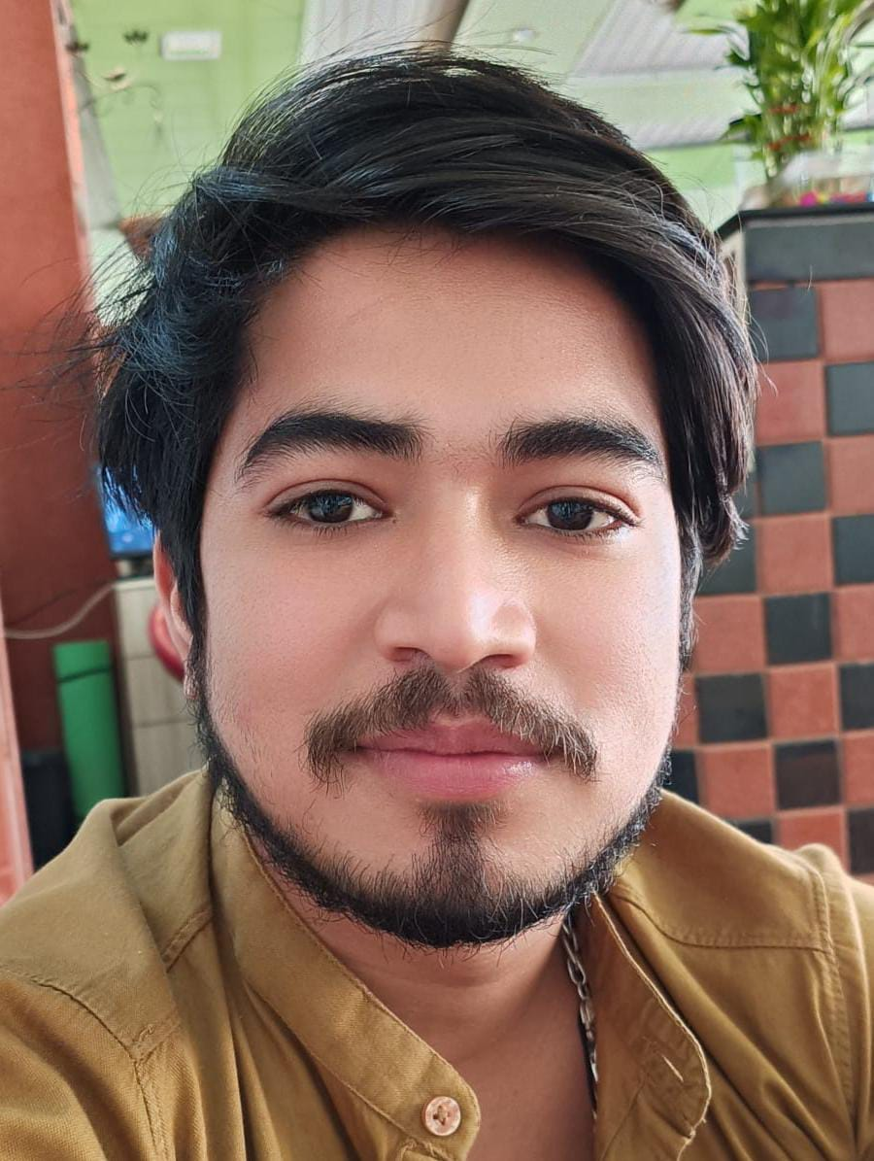
Date of birth :15-08-2000
Present Address: chandreshwar nagar, ward no. 01, Rishikesh, Dehradun
Pin code, 249201
Phone No: + 917300942508
Email Addresses: lovelyprince9720@gmail.com
Nationality: Indian
Marital Status: Unmarried

Objective:
Looking for a quality environment where my knowledge & skills can be shared for the benefit of my future achievements & development of the organization.

Skills:

- Ability to take responsibility of receiving materials
- Ability to maintain the requisition properly
- Ability to control wastage properly
- Ability to plan work schedule
- Ability to assign duties in accordance to the work schedule

Work Experience:
- Presently working in Mamma mia inn since march 2019 as manager & barista
- Worked in French bakery, ram jhula, rishikesh as Coffee maker from March 2016 to January 2019.

Academic Information:

Professional qualifications:

- Completed Diploma Course in Food Production and Patisserie from AH & LA.

College:

Examination passed | College | University | Year | % Marks
Inter midiate | National institute of open board, haridwar | Open board | 2021 | 61%
Schooling:

Language Proficiency:
- English, Hindi.

Hobbies:
- Cooking, Playing Volley Ball, Mountain Trekking.

Declaration:
I hereby declare that the above bio-data furnished by me is true to the best of my knowledge.

(Prince kumar)

