**RESUME**

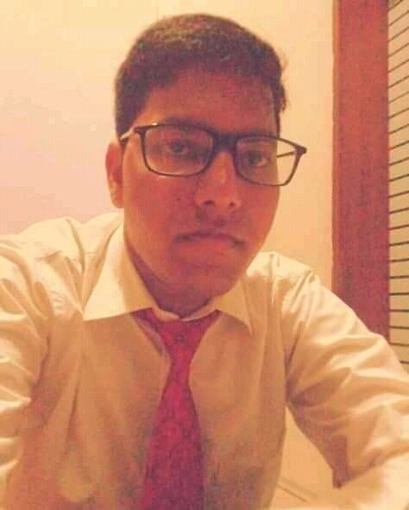

**Rahul Joshi**

**ADDRESS – Khari Khurd,20 Footi Road Shyampur, RISHIKESH, (DEHRADUN)**

**MOB – 91- 9548435297**

**Email :** [**rahuljoshi5321@gmail.com**](mailto:rahuljoshi5321@gmail.com)

**OBJECTIVE :**

To explore prospective markets for opportunities to create avenues for the organization, in which I can give 100% of my skills and knowledge for the growth of the organization as well as enjoying my work.

**ACADEMIC QUALIFICATION :**

* 10th Pass out from CBSE Boards 2013.
* 12th Pass Out from CBSE Board 2015.
* BA Pass Out From Uttarakhand Open University in Haldwani, Uttarakhand 2018. )
* 6 months diploma in basic computer.
* 4 months English speaking course.

**PROFESSIONAL QUALIFICATION :**

* One Year Diploma in Front Office From IHM Rishikesh

(Affilated to Shri Dev Suman University,Uttarakhand 2017- 2018)

**EXPERIENCE:-**

* Completed Industrial Trainning From MercureHotel,Dwarka(Accor Group)From 24th Oct 2017 to 23th Jan 2018)
* Worked as Front office associate at Radisson Blu hotel,indore(Carlson group)From 24th feb 2018 to 27th September)
* Worked as Front office associate at Ramada hotel, neemrana(Wyndham group)From 4th oct 2018 to 2nd Dec 2019)
* Worked as Front office supervisor at Golden Tulip hotel, Haridwar From 1stfeb 2020 to 12th November 2020.
* Worked as Front Office Duty Manager at Harmony On Ganges, Laxmi Heights, hotel Tapovan, Rishikesh From 24th November to till now.

**Strengths:-**

* Quick Learner
* Time Valuing Person

**Skills:-**

* Ms Word,Excel
* Internet And Online Work
* IDS Software
* Opera
* Lingertech Software
* Lucid Software
* Webline Software

**PERSONAL INFORMATION:-**

* **Father name** - Mr. Dwarika Prasad Joshi
* **Date of birth** - 25-06-1999
* **Nationality-** - Indian
* **Marital status**- - Unmarried
* **Languages known**  - Hindi & English

**Declaration:**-

I here by declare that all the information given above is true with best of my knowledge.

Date –

Place - (Rahul Joshi)