CURRICULUM VITAE
BHUPENDRA S RAWAT  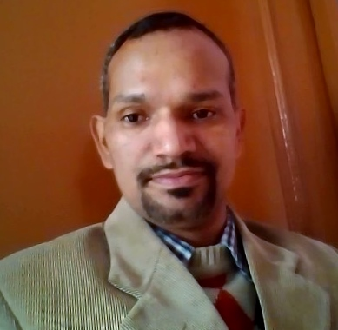  Email  bhupesh03rawat@gmail.com  Mobile No-  7838874234  Address  S/o Mr.G.S.RWAT,  House No.151,  Village Mawana  Post Office Gholtir  District Rudrapryag  Uttarakhand  Pin Code: 246171  Personal Data  Date Of Birth: 30/10/1981  Sex: Male  Nationality: Indian  Marital Status: Single  Languages Known  English, Hindi  Hobbies:  Movies, Music & Writing | Objective:  To become an accomplished professional by contributing to organizational development in competitive environment with hard work, dedication and take on increasing responsibility leading to professional and personal satisfaction.  Professional Education:  - Master of Tourism Administration (M.T.A.) 2001-03 from H.N.B. Garhwal University, Srinagar.
Assets:

- Highly motivated to work as a team.

- Adjustable to any environment.

- Effective Communication skill qualities.

Education:

Examination | Board/University | Year
B.Sc | H.N.B.Garhwal University | 2000
12th | U.P. Board | 1997
10th | U. P. Board | 1995

Working Experience

- Two Months Summer training (during May 2002 to Jun 2002) at SURBEE RESORTS MUSSORRIE.

- Worked in REGENCY TOURS PVT.LTD, KAROL BAGH for 01 Year & 5 Months (during Mar 2004 to Jul 2005) as Domestic Tour Executive.

- Worked in ISH TRAVEL & TOURS PVT. LTD., CONNAUGHT PLACE for 09 Years & 01 Month (During Sep 2005 to Oct 2014) as Senior Executive Domestic Tour Division.

- Worked in TRAVEL LION HOLIDAYS PVT. LTD, NOIDA UP for 01 Year & 02 Month (During March 2016 to May 2017) as Manger Operations.

- Worked in DIVINE RESORT & SPA RISHIKESH, DSO GHAZIBAD for 01 Year & 7 Months (During Sep 2017 to Apr 2019) as Reservation Manger.

- Worked in MONAL RESORT , RUDRAPRAYAG for 01 Year (During May 2019 to Apr 2020) as Operation Manager

Date BHUPENDRA S.RAWAT

