CURRICULUM VITAE

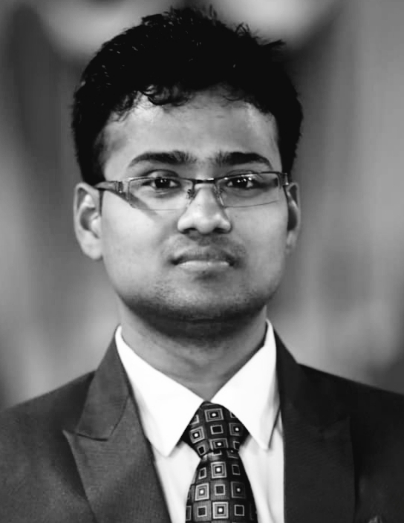
Himanshu Negi
Bipin Rawat Enclave no.2
Central Hopetown, Selaqui
Dehradun, Uttarakhand
Contact No.  7983835030
WhatsApp No. - 7983835030
Email Id : - himanshun60@gmail.com
Career Objective

To enter into a long-term relationship with an organization where I can utilize my skills and contribute to the growth of the organization through my knowledge, dedication and hard work.

Educational Qualification
- High School from Rajasthan Board in 2009.
- Intermediate from Rajasthan Board in 2011.
- Completed BBA in Hotel Management from Institute of hotel management studies Kotdwar, Pouri Garhwal (Uttrakhand) 2014.
Computer Knowledge
- Having Knowledge of Basic Computer Applications word, excel, power point.
Working Experience
- Completed six months industrial training in Hotel Radisson Blu MBD Ludhiana in 15 July 2013 to 15 Dec 2013
- Six month working experience in Hotel Rajpur Height , Dehradun as a GSA from December 2013 to June 2014 (16 suites keys)
- Thirteen month working experience in SRS Group of Hotel Lakshya, Haridwar as Sr.GSA from June 2014 to July 2015 (78 keys)
- One year working experience in (Pre-Opening)Le Roi Groups of hotel and Resorts, Haridwar as a Sr. GSA from August 2015 to July 2016 (92 keys)
- One year three month experience in Hotel Four Points by Sheraton, Dehradun as a Sr.GSA & Desk Controller July 2016 to oct 2017 (65 keys)
- One year working experience as a Trainee supervisor in Hotel Four Points by Sheraton, Dehradun from Oct 2017 to Oct 2018 (65 keys)
- One year working experience in Hotel Four points by Sheraton, Dehradun as a housekeeping supervisor Oct 2018 to Sep 2019 (65 keys)
- Sixteen month working experience in Nanu Resort Beach and Spa, Betalbatim, Salcete Goa as a Housekeeping Supervisor Oct 2019 to Jan 2021 (92 rooms ,16 villas ) 108 keys
- One year working experience in Fortune hospitality services (Under Reliance Green Township), Jamnagar, Gujarat as a Housekeeping Executive from Jan 2021 to Dec 2021 (361 keys)
- Presently working in Four Leaf Service Suite, Haridwar (76 keys) as a Astt Housekeeper from Jan 2022 to till date.
Achievement
- I Got Appreciation Certificate in Culinary competition
- I Got Two Time Best Employee of the Month Certificate
- I Got four times Best Emotag Employee Certificate
- I Got Ist position certificate in Towel Art competition
- I Got Kudos Star certificate in Housekeeping Department
- I Got Life Saver Certificate (IMA Blood bank Uttarakhand)
- I Got appreciation certificate in Beach Cleaning
Personal Profile
Fathers Name Mr Narendra Singh Negi
Date of Birth 12th July 1993
Gender Male
Religion Hindu
Nationality Indian
Marital status Unmarried
Language Known Hindi. & English
Hobbies Listening Music, painting
Declaration

I hereby declare that all statements above are true and correct to the best of my knowledge
and Believe.

Date:
Place: Haridwar, Uttarakhand (Himanshu Negi)

