RESUME
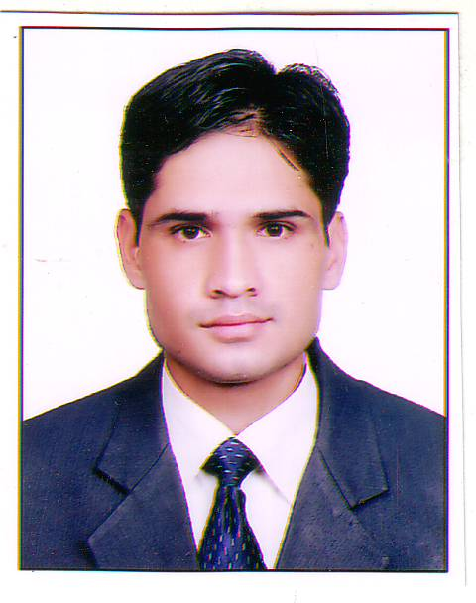
BIPIN KUMAR CHAUDHARY
Vill-Bhelda Bara Post office Dada Mandi
Tehsil Katdwar Distt-Pauri Garhwal (Uttrakhand)
Mobile: 09690317088 , 8968515271
E-mail: chaudharyvipin896@gmail.com

CAREER OBJECTIVE:

To work for an organization that nurtures its resources by promoting commitment innovation and teamwork to bring out the best in them. To purse career in the service industry and to be excel in my chosen profession.

WORK EXPERIENCE:

- Done six month Industrial Training from The Pride Hotel Pune. (Best Western)
- One year working experience as a Hotel operation Trainee in Hotel Country INN & Suites Ludhiana a Group of Carison.
- One year working experience as a Assistant Steward in Hotel Country INN & Suites Ludhiana a Group of Carison.
- One year working experience as a Assistant Steward in Fortune Park Klassik Hotel by Welcome Group (ITC) (Ludhiana)
- One year working experience as a Steward in Fortune Park Klassik Hotel by Welcome Group (ITC) (Ludhiana)
- One year working experience as a Sr. Steward in Fortune Park Klassik Hotel by Welcome Group (ITC) (Ludhiana)
- Total three and Half year working experience in Hotel park Klassic Hotel by Welcome Group (ITC) Ludhiana.
- Six month working experience as a Captain in Best Western Amritsar.
- One year working experience F&B executive Mansarovar Paradise, Muradabad Uttar Pradesh.
- Two year working experience as a Sr. Caption In Fortune Park KLassik Ludhiana .
- One Year working as a Sr.Caption in( Royal Orchid hotels group Ludhiana )last six month.
- Now a days working as a Fnb Excutive in Golden Tulip, Udaipur, Rajasthan.
- Total 12 year experiences.

QUALIFICATION:

- High School from U.P. Board.
- Intermediate from U.P. Board.
- Graduation from (Hemwati Nandan Bahuganaj) from Garhwal University.

LANGUAGE KNOWN:

- English.
- Hindi.
- Punjabi

HOBBIES:

- Internet Surfing.
- Listening to music.
- Playing Cricket.

RESPONSIBILITY:

- Receiving of Guest.
- Answering of phone calls and enquiries.
- Guest complains and cashiering.

IT SKILLS:

- MS Excel.
- MS Word.
- Working on IDS Enterprise V 4.1

PERSONAL PROFILE:

Date of Birth : 20th June. 1981
Father Name : Mr. Sohan Lal Chaudhary
Marital Status : Married.
Sex : Male.
Religion : Hindu.
Nationality : Indian.

DECLARATION:

I hereby declare that above mentioned information details are true to the best of my best of knowledge.

Date: ..
Place: (BIPIN KUMAR CHAUDHARY)

